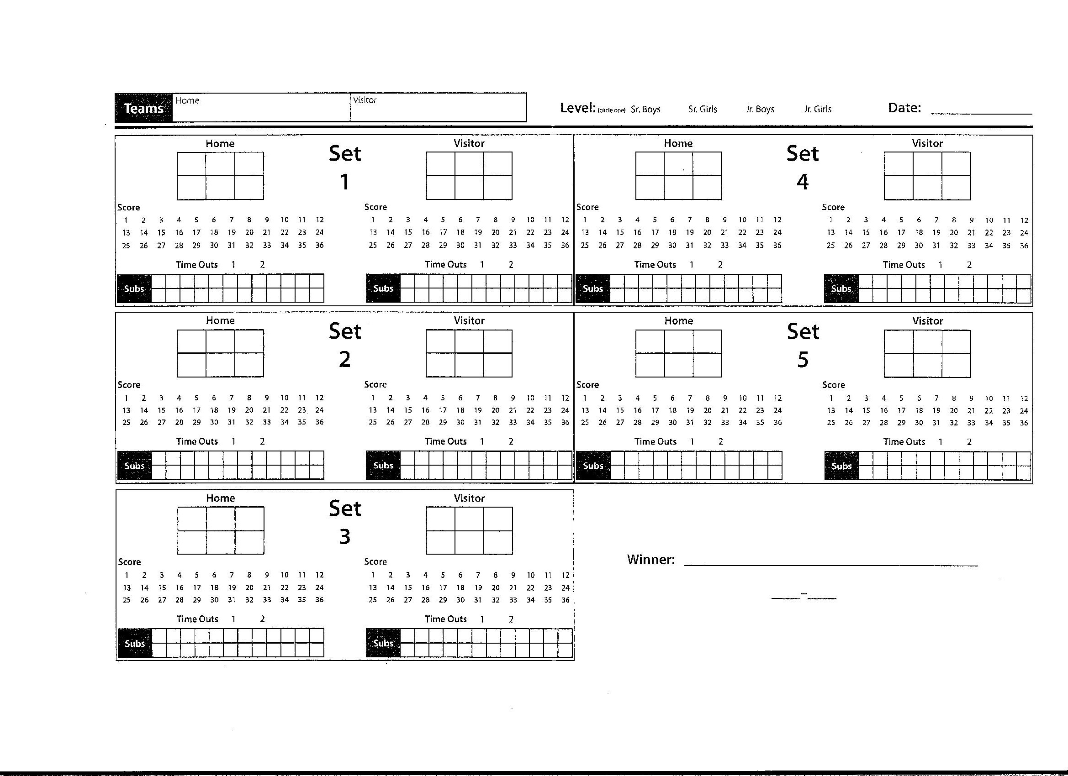
EPSB Junior High Volleyball Score Sheet

